Cybersecurity Programs — Flowcharts (Questions 1–15)
Authentication, SQL injection prevention, MFA/OTP, password security, command injection, and secure network operations.

1. Login Authentication + 3 Failed Attempts
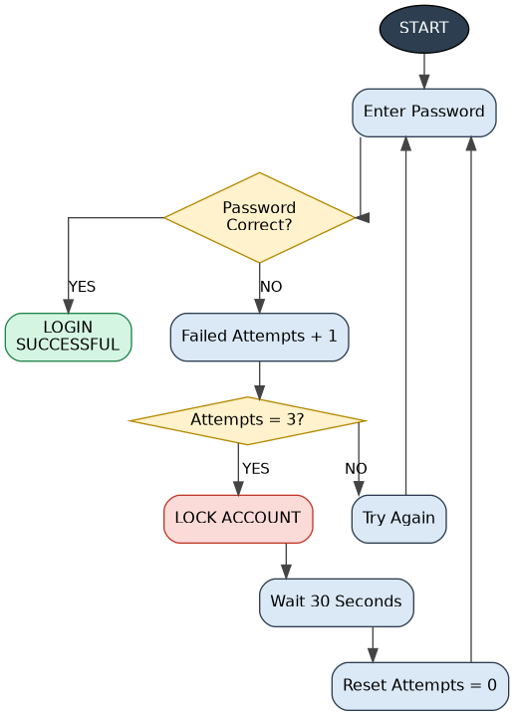
The program locks the account for 30 seconds after three consecutive failed attempts.

2. Fetch Product Details Using Parameterized Query
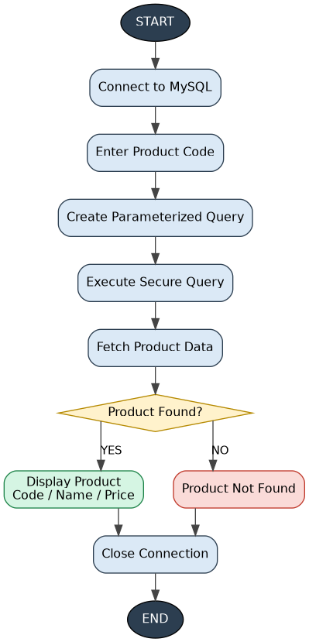
The query retrieves productCode, productName, and buyPrice using %s parameterization.

3. Retrieve Customer Details
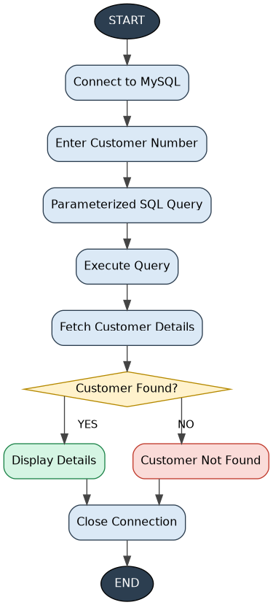
The program searches the customers table using a parameterized query.

4. Customer Authentication
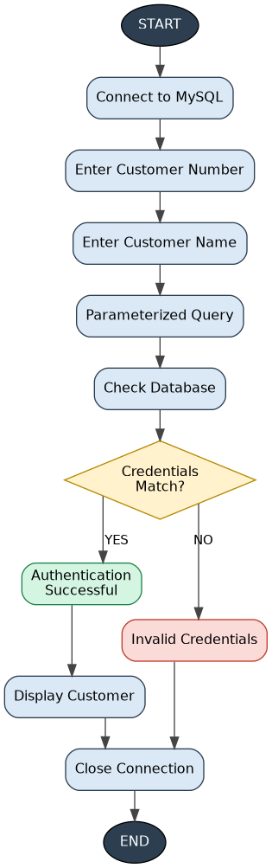
The program checks both customerNumber and customerName securely.

5. Dictionary-Based Password Attack
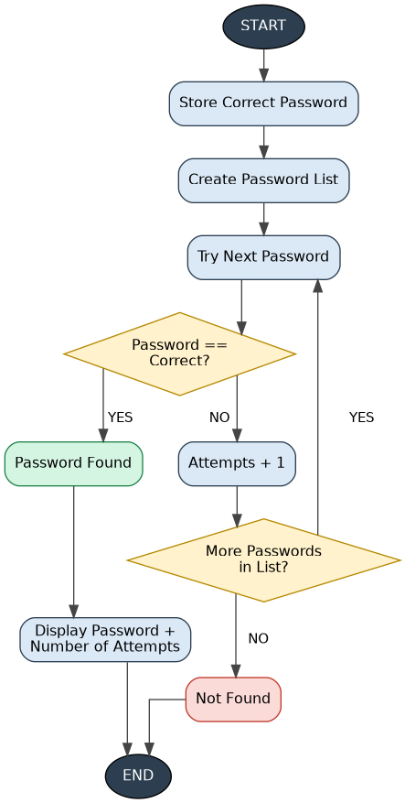
The program tests common passwords until the correct password is found and displays the number of attempts.

6. MFA Using Password + TOTP
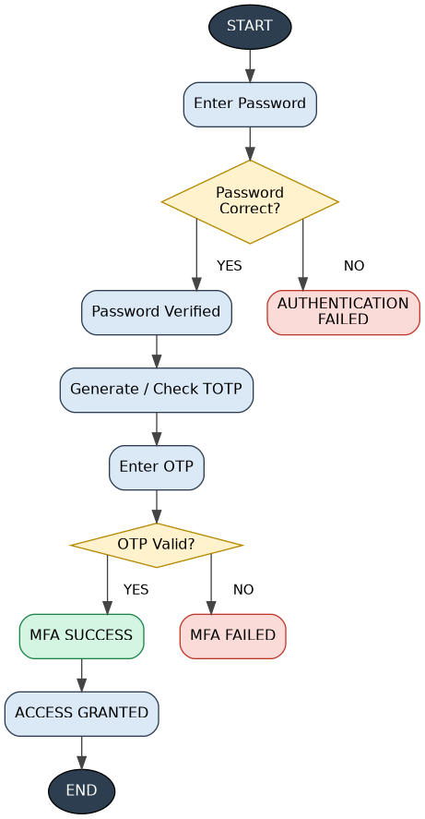
The program uses the password as the first factor and a TOTP generated with pyotp as the second factor.

7. Password Strength Checker
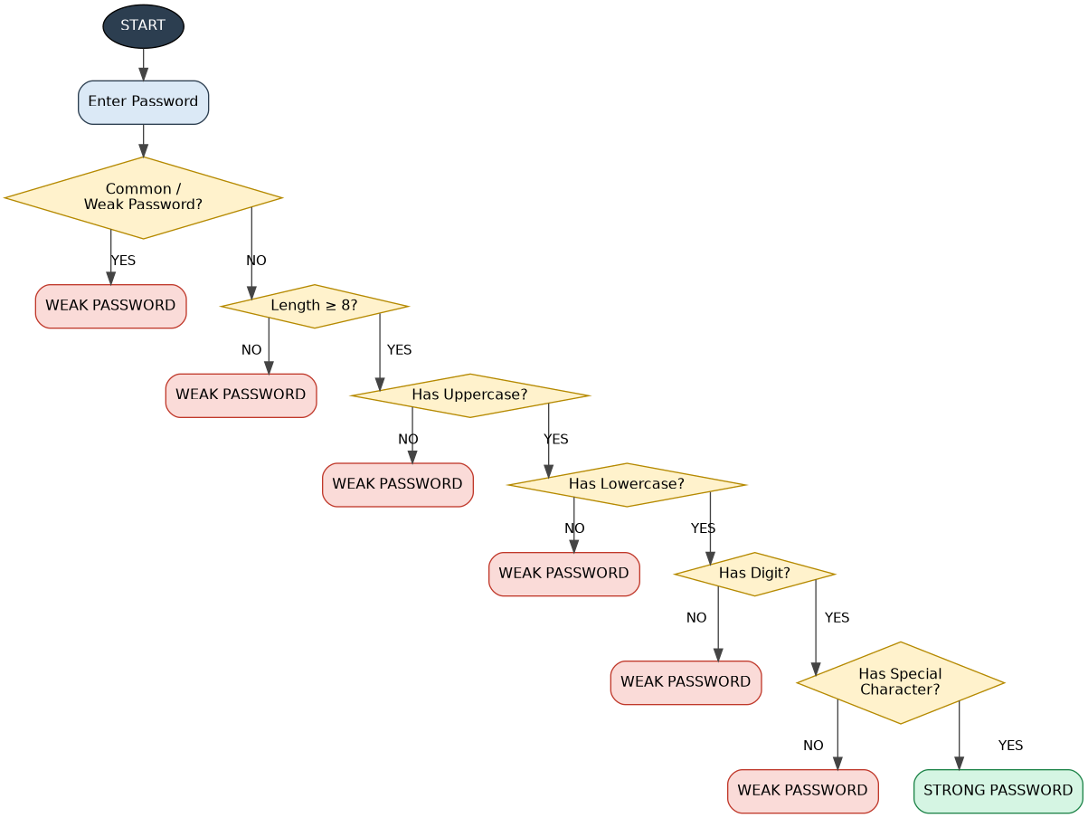
The checks include length, uppercase, lowercase, digits, special characters, and common weak passwords.

8. Mobile OTP Verification
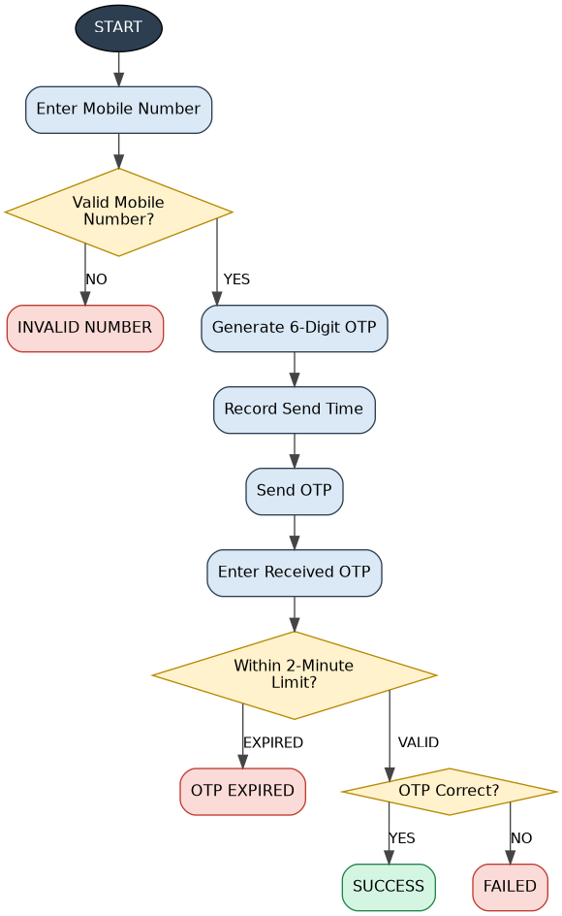
The program generates a six-digit OTP, gives it a 2-minute validity period, and checks the entered OTP.

9. MFA Using Password + Email OTP
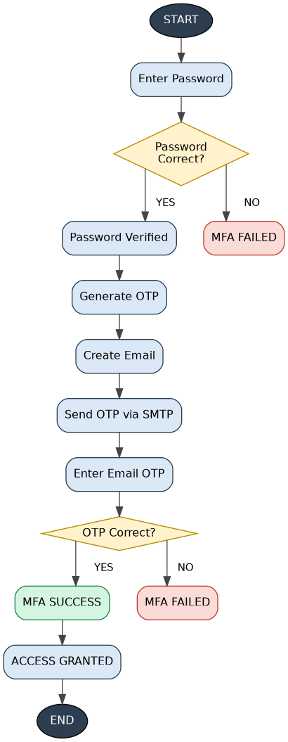
The program uses the password as factor one and an OTP sent through Gmail SMTP as factor two.

10. Secure Login Using getpass
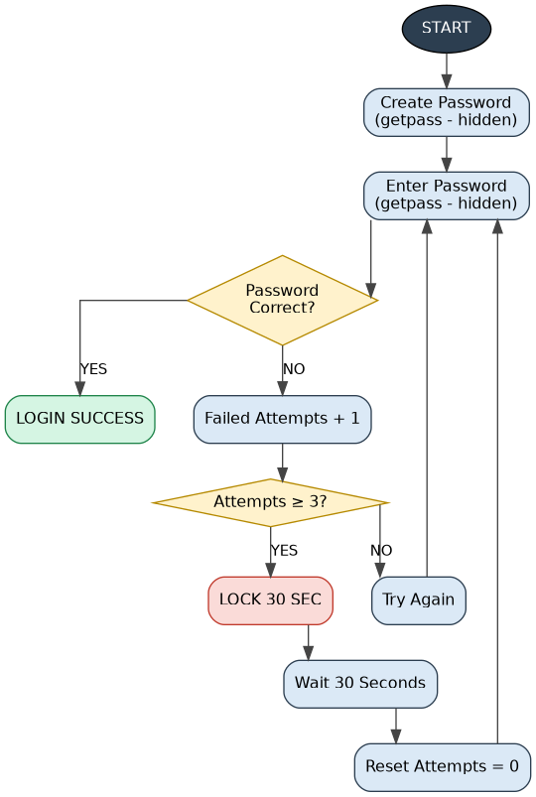
The program uses getpass so passwords are not displayed on the screen, and applies a 30-second lockout after three failures.

11. Bcrypt Password Hashing + Lockout
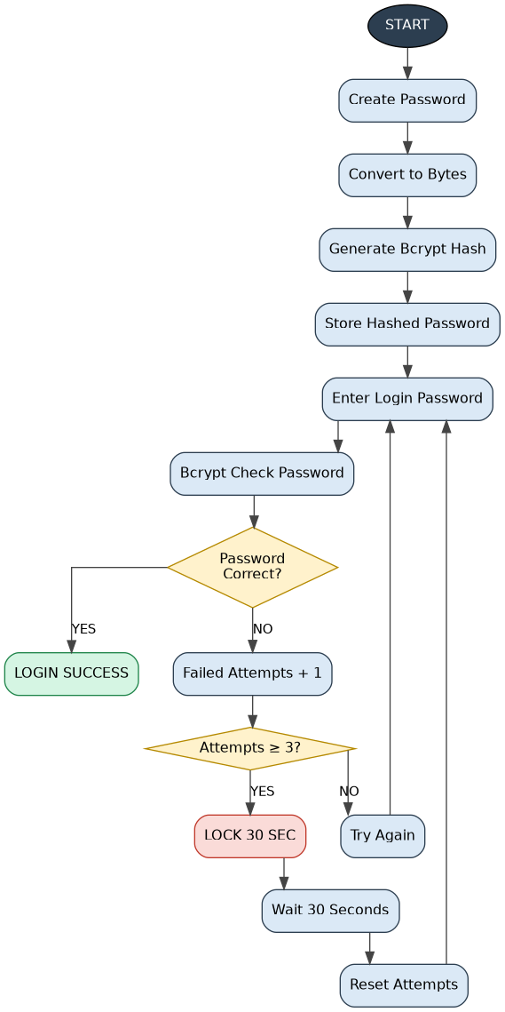
The password is hashed with bcrypt.hashpw() and verified using bcrypt.checkpw().

12. Allowlisted System Commands
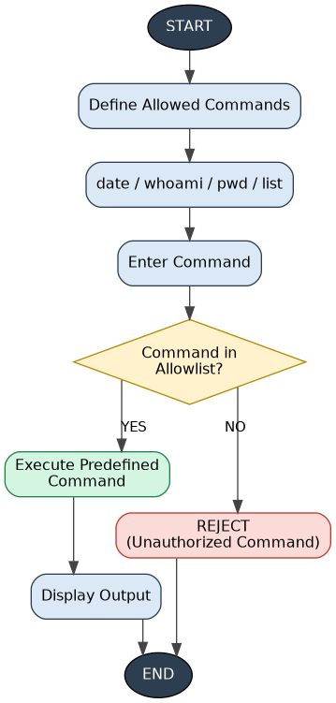
Only predefined commands are accepted; the user cannot directly provide an arbitrary system command.

13. Safe .txt File Search
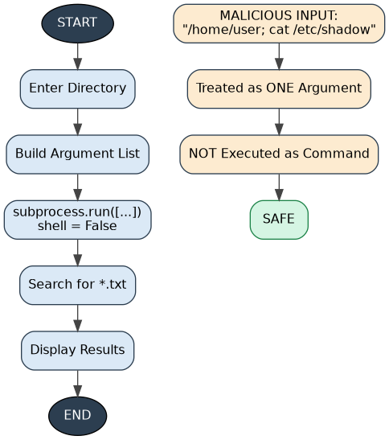
The program uses subprocess.run() with a list of arguments and does not use shell=True, protecting against command injection.

14. Validate IP + Secure Ping
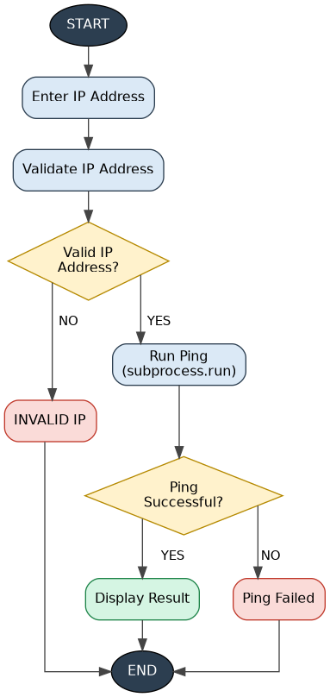
The program validates the address using ipaddress.ip_address() before passing it to subprocess.run() without shell=True.

15. Network Diagnostic Tool
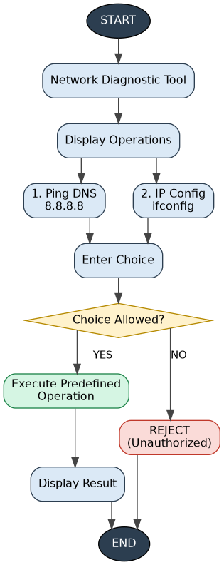
The program allowlists two operations: pinging 8.8.8.8 and displaying IP configuration.

Super-Short Revision Flow
- 1. PASSWORD → 3 FAILS → LOCK 30 SEC
- 2. PRODUCT CODE → PARAMETERIZED QUERY → PRODUCT
- 3. CUSTOMER NUMBER → PARAMETERIZED QUERY → CUSTOMER
- 4. CUSTOMER NUMBER + NAME → MATCH → AUTHENTICATE
- 5. PASSWORD LIST → TRY → MATCH → FOUND
- 6. PASSWORD → TOTP → MFA
- 7. PASSWORD → CHECK RULES → STRONG / WEAK
- 8. MOBILE → OTP → 2 MIN → VERIFY
- 9. PASSWORD → EMAIL OTP → MFA
- 10. PASSWORD → getpass → 3 FAILS → LOCK
- 11. PASSWORD → BCRYPT HASH → VERIFY → LOCK
- 12. COMMAND → ALLOWLIST → EXECUTE / REJECT
- 13. DIRECTORY → subprocess → .TXT SEARCH → SAFE
- 14. IP → VALIDATE → PING → RESULT
- 15. CHOICE → ALLOWLIST → NETWORK OPERATION

Part 2 — Core Concepts Explained
Every flowchart above is built on one of these six ideas. Each threat (⚠) is paired with the defence (🛡) that neutralises it.

1 Account Security & Rate Limiting
⚠ THE THREAT — Brute-Force Attacks
When a login system has no limits on login attempts, an attacker can use automated software to guess thousands of passwords every second until it finds the right one.

🛡 THE DEFENCE — Account Lockouts
Systems enforce rate limiting. After a set number of consecutive failed attempts (e.g. three), the account is temporarily locked for a fixed period (e.g. 30 seconds).
This minor delay completely neutralises the speed advantage of automated guessing tools, making brute-force attacks practically impossible.

2 Database Protection & Parameterised Queries
⚠ THE THREAT — SQL Injection
Databases store highly sensitive information, such as product lists and customer profiles. When a poorly protected application stitches a user's typed text directly into its internal database commands, an attacker can type database commands instead of a normal search term.
This can trick the system into exposing private data or bypassing authentication entirely.

🛡 THE DEFENCE — Parameterisation
Security relies on strictly separating instructions from user data. Systems use pre-defined templates called parameterised queries: the database is told the query structure in advance, and user input is treated strictly as safe data — never as executable code.
Even if an attacker inputs database commands, the database safely ignores them and treats the input as a harmless, long search term.

3 Understanding Password Attacks
⚠ THE THREAT — Dictionary Attacks
Users frequently choose common words, names, or simple patterns for their passwords. Attackers exploit this predictable behaviour with dictionary-based password attacks.

⚙ HOW IT WORKS
Rather than guessing random character combinations, the attacker's software loads a pre-compiled list of common words and leaked weak passwords, then systematically tests them one by one against a target account until it finds a match.
This highlights why simply having a password is not enough — it must be completely unpredictable.

4 Multi-Factor Authentication (MFA)
🔑 THE CONCEPT
Relying on just a single password (something you know) is risky — passwords can be leaked, shared, or guessed. MFA adds extra, independent layers of security.
To log in, a user must provide at least two different categories of verification:
• First factor — something you know (your standard account password)
• Second factor — something you have (a physical device, mobile phone, or access to your email account)

Types of Second Factors
📲 TOTP — Time-Based One-Time Passwords
A secure authenticator app on the user's mobile device continuously generates a unique 6-digit code that automatically changes (usually every 30 seconds). The app and server share a mathematical secret key, so only the user's physical phone can generate the correct code at that exact moment.

💬 Mobile SMS Verification
The system generates a random 6-digit code and texts it to the user's pre-registered mobile number. To prevent intercepted or forgotten messages from being reused, these codes are given a strict expiry window (such as 2 minutes).

📧 Email OTP
Similar to mobile messages, a temporary, expiring verification code is sent to the user's registered email inbox using secure mail transfer protocols — requiring the user to prove they have access to that specific email account.

5 Password Strengthening & Storage
✅ Password Strength Checkers
To prevent dictionary attacks, systems enforce rules that make passwords highly complex. A checker validates a minimum length (at least 8 characters), a mix of uppercase and lowercase letters, numbers and special symbols, and rejects anything on a list of common, weak passwords.

🙈 Input Masking
To protect users from "shoulder surfing" — someone reading the screen over their shoulder — secure login interfaces mask password entry. As characters are typed, they're hidden from the screen so they can't be read.

🔒 Password Hashing
Systems must never store passwords in plain text — if an attacker breaches the database, plain-text passwords would immediately expose every account.
Instead, a password is run through a hashing algorithm at creation time, converting it into a unique, irreversible fingerprint (a hash). At login, the entered password is hashed the same way and compared to the stored fingerprint.

6 Safe System Operations & Preventing Command Injection
⚠ THE THREAT — Command Injection
Computers routinely run background tasks to check network health or look up files. If an application passes what a user types directly to the operating system shell, an attacker can input special symbols (like semicolons or "and" signs) to trick the computer into running unauthorized, destructive commands.

Three Layers of Defence
🛡 1 · Allowlisting
The most secure approach: restrict user choices exclusively to a predefined, pre-approved list of operations (e.g. only running a specific network ping or checking system configuration). If the input doesn't exactly match an option on the list, the operation is instantly blocked.

🛡 2 · Running Commands Without a Shell
When a program must search files or run background utilities, it sends the command and its inputs directly to the OS as a structured list of individual arguments. Bypassing the shell means user input is always treated as plain text, never as extra instructions.

🛡 3 · Input Validation
Before user input touches a system utility, the application verifies it strictly fits the correct format — e.g. confirming an input is formatted exactly like a valid IP address before running a diagnostic ping. Anything that fails validation is instantly rejected, stopping command injection before it can start.

